Celebrating the 150th. Anniversary of the birth of W. B. Yeats
William Butler Yeats (1865-1939)
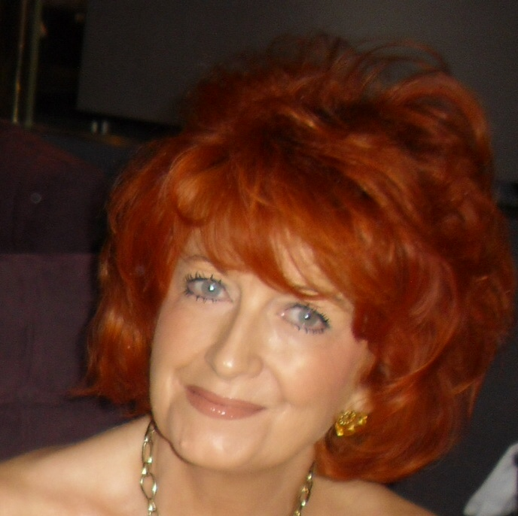
Sheighle Birdthistle is an Irish poet living in Provence France. While studying at the University of Limerick she spent a semester at Harvard Summer School studying the poetry of Sylvia Plath and Anne Sexton. Sheighle has a Masters Degree in Modern English Literature and is Director/Founder of The Poetry Corner in Aix en Provence. France.

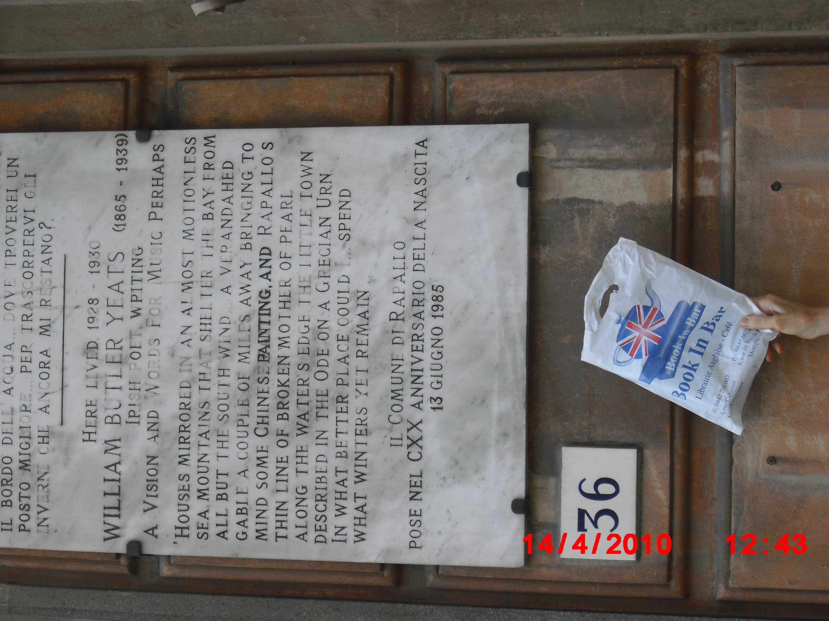
This photograph shows a plaque in Rapallo commemorating William Butler Yeats who lived in this building from 1928 to 1930. I am holding a bag from Book in Bar. Aix en Provence where I present The Poetry Corner on the last Friday of each month. The photograph was taken April14th. 2010

The Poetry Corner.
William Butler Yeats. (1865-1939)
William Butler Yeats was born in Dublin June 13th. 1865. He was the eldest of six children born to John Butler Yeats and his wife Susan Pollexfen. Susan was part of a wealthy family from
Sligo in the west of Ireland. Her family welcomed John B. Yeats who was the son of a Protestant churchman, who like his father and grandfather had studied at Trinity College Dublin. However, they were dismayed when John Butler Yeats abandoned his career as a barrister in favour of being a portrait artist. Unfortunately he was never financially successful as an artist. The family moved from home to home between Ireland and England in pursuit of this artistic career. Instead of financial security the young Yeats family, had challenging conversation and encouragement in the discovery of their talents. So it was that as a boy, attending High School in Dublin, W.B. Yeats was accustomed to genteel poverty as were many Irish writers of the time. Willie, as he was called, travelled each morning by train with his father Willie, to school and his father to his studio. They discussed and enjoyed poetry during these daily journeys. When the time came to choose a
career W.B. decided to attend The School of Art in Dublin rather than Trinity College Dublin, thus breaking with family tradition. There, he met and was impressed by other writers and artists such as James Clarence Mangan and Standish O’Grady and so it was not surprising that he decided that he wanted to be a poet. He began to use the beautiful folk tales of Sligo that his mother had told him and his siblings when they were children. John Yeats encouraged Willie by recklessly saying, that a gentleman should follow his desires regardless of money considerations. From a young age Willie was interested in nationalism and translations of Irish writing into English and as he matured so did this interest in Irish literature. He thought that he could recreate Ireland’s forgotten intellectual heritage. It was while he attended the School of Art that some of his first poems were published in the Dublin University Review.

In March 1888 John Butler Yeats once more moved his family from Dublin to London. The family was almost destitute, both money and food were in short supply. Willie’s small amounts of money from magazine publications paid almost all the household expenses. When his sister Lily began working in an embroidery shop earning ten shillings a week, it was a cause for celebration. Around this time Mrs Yeats suffered a stroke. She virtually gave up on life when there followed a second stroke, and she died in 1900.

Yeats was twenty fours years old when he met, and fell in love, with Maud Gonne. She was tall and beautiful a revolutionary and an actress. Born in England and educated in France, Maud Gonne was an amazing and energetic woman, she had a son who died in infancy and a daughter Iseult, they were the children of her liaison with a married French rebel politician Lucien Millevoye. It was in France that Maud Gonne began her lifelong interest and fight for the Irish nationalist cause. Yeats wrote poetry for Maud Gonne and a play, The Countess Kathleen. The poetry was full of love and longing. Melancholia invades and invests the poetry of Yeats from the moment her meets Maud Gonne. His lifetime of unrequited love pulsates in his words – so many words cherishing and exalting this beautiful woman. Maud Gonne was a contrast of soft beauty and ruthless rebel and this touched the soul of Yeats. He proposed to her in 1891 and was refused with the words that the world would thank her for not marrying him. Yeats repeated his proposal many many times but she continued to refuse. They remained lifelong friends and she continued to figure in his poetry. Years later Yeats proposed to Gonne’s daughter Iseult and she also refused him. Iseult married the highly controversial writer Francis Stuart they had two children but the marriage did not survive. Francis Stuart later married a German woman and after her death he married, in the 1980’s the Irish artist Fionnuala Graham who was more than forty years younger than Stuart. I remember Fionnuala Graham the budding artist we shared the same classroom in my convent school in Ireland.

Maud Gonne witnessed the cruel evictions that took place on a regular basis in Ireland and was deeply moved by the plight of the poor Irish people. She became involved in the Irish struggle for Independence and is buried in the Republican plot with the other Irish patriots. Her husband John Mac Bride was executed with James Connolly after the 1916 Easter Rising. Maud Gonne and John Mac Bride had a son Sean who was born in Paris in 1904. His first language was French. He was awarded the Nobel Peace Prize in 1974 and the Lenin Peace Prize in 1975. He died January 15th. 1988.

Yeats was hugely influenced by Gonne’s revolutionary ideals and he impressed her with his view that his literary movement would work equally alongside her battle to forge an Independent Ireland. Yeats’ early poetry was romantic, modelled on poets such as Spenser and Shelley and the Pre-Raphaelites. As his own personal style developed he found that in Ireland he had a huge store of subject matter. His familiarity with the west of Ireland, and Sligo in particular where fairy and folk tales dealt with the mysterious otherworld, with ghosts and the supernatural, gave Yeats inspiration and fascinated his imagination. He delved into ancient Irish legends and already by the age of twenty three he had begun to grow into an original and accomplished poet.

It was from the sense of homesickness for Sligo that Yeats wrote “The Lake Isle of Innisfree”. With this poem Yeats considered that he had found his own articulation, his own music. The poem has a musical rhythm with its lines of uniform feet. The lines flow easily one on to the next in a fluid telling of the story within the poem. Yeats had found his voice and a place in poetry. He also began to forge a sense of self dignity a composure, which contrasted greatly with his father’s lack of grace and willpower. Although he began to expand his horizons Yeats’ career progressed slowly. In Dublin he had been published in Irish magazines and now in London he had to start again in London’s literary life. He began to be published in the Scots Observer and the National Observer and he did much editing including editing Blake whose work appealed to him.

Yeats was very interested in the Occult and the Supernatural. He was always searching within and without for answers to the questions of existence. He joined the Theosophists, who sought knowledge of the Absolute, through intuition and spiritual ecstasy. However, Yeats was asked to leave the society as he continued to demand and desire evidence. Yeats was continuously pulled between his desire to believe and his ever anxious questioning. There was a lull in Irish politics after the death of Parnell 1891 (the leader of the Irish Parliamentary party) and Yeats considered the time right for launching a literary movement. His form of revolutionary work was to be done through writing whereas Maud Gonne his beloved muse was ultra political. This revolutionary literature was to dignify Ireland’s sense of self and make Irish readers aware of their heritage of a Gaelic civilization. It would be a new literature not dominated by political rhetoric but abundant in its return to past traditions. In 1892 Yeats published The Celtic Twilight and it gave its name to the Irish Literary movement as well as showing Yeats’ great intellect and leadership. The Irish Literary Renaissance came into being. Yeats’ work took many shapes and forms as it moved forward. He moved from his desire to write popular poetry to poetry that was intense and rarefied. He wrote beautiful language with delicacy and style. The tone of his love poetry changed and he wrote epic poetry and poetry about the difficulty and hard work that goes into writing poetry that seems simple and spontaneous.
Yeats was very hurt and surprised when in 1903 Maud Gonne married John Mac Bride, another revolutionary. Now he could only record memories and old hopes of his love and pay tribute to her great beauty and he compares her to Helen of Troy.
Yeats became disillusioned with Irish politics and returned to his ambition to create an Irish theatre. He was helped in this by Lady Gregory the widow of an Anglo-Irish landlord. He spent many summers at Coole Park her house in Co. Galway and it was the perfect ambience for his creative writing and poetry. With determination and able assistance from Lady Gregory he brought a national theatre into being. Yeats plays were performed, including Cathleen Ni Houlihan with Maud Gonne in the leading role. When the Abbey Theatre was established in 1904 Yeats became its production manager until 1910. His was an unselfish role as manager. He encouraged younger dramatists as the theatre moved away from his idea of poetic drama to a drama of realism. Synge’s The Playboy of the Western World in 1907 caused uproar as it was considered a slur on Irish manhood. Despite hostile audiences, Yeats continued to stage the play. Yeats next volume of poetry was one of completely different poems lacking its former mysticism. He used savage satire and attacked the ungrateful philistines in defence of Art. He wrote contrary to his normal style and denigrated some of his earlier work through extreme form and style. He was venting his frustration and frustrated passion for Maud Gonne through poetry.

The Easter Rising of 1916 took Yeats completely by surprise and the revolutionaries whom he had come to despise, now attained heroic stature. A terrible beauty was born. Maud Gonne’s husband, from whom she was separated, was one of the sixteen leaders executed and Yeats went to France and proposed to her once again. Again he was refused both by Maud and Iseult. In October 1917 he married Georgie Hyde Lees and his marriage gave a serenity and order to his life. Through his interest in unusual and extensive reading, and the mixture of his romantic and realistic poetry, his work seemed to have a rebirth a renaissance. He wrote with authority and could blend the beautiful and the tragic. He gave significance to the ordinary things and events of life that he had avoided earlier and his voice spoke to the people.

Yeats was made a Senator of the Irish Free State and was active and constructive in his role as Senator and he was listened to with respect. In 1923 William Butler Yeats was awarded the Nobel Prize for Literature and this gave public recognition of his work. He bought his first house in Co. Galway and called it Thoor Ballylee it was a medieval Norman tower and he and his wife restored it and they lived there with their son and daughter. Yeats work continued to shine and mature and he wrote with fervour and energy despite illness and impending age and death.
He died in France and was buried in Roquebrune in January 1939. His body was brought to Ireland and interred at Drumcliff in September 1948.

Bibliography.
Jeffares, A. Norman., (1990) (end) W.B. Yeats Selected Poetry. Pan Books Ltd., London.
Jeffares, A. Norman., (2000) York Notes Advanced. W.B. Yeats Selected Poems. York Press. London.
Shortall, Barry. (2002) Willie & Maud The Collins Press. Cork.
Birdthistle, Sheighle. (2001) U.L. Notes. Ireland.

